
ALLIANCE UNIVERSITY
Alliance School of Advanced Computing
Student Name: Yuvraj Paarth
Register Number: PROV/ASAC/MCA/7/26/083
Project Name: Design and Prototyping of a User-Centered Coffee Ordering Mobile App (Do Bhai Coffee Co.) Using UI/UX Design Principles
ACADEMIC YEAR: 2026-2028
Department of Computer Applications
Program - Master of Computer Applications
Semester 1

ACKNOWLEDGEMENT
I would like to express my sincere gratitude to everyone who supported and guided me throughout the successful completion of this project.
I am thankful to my Project Guide for providing valuable guidance, suggestions, encouragement, and continuous support throughout the development of this project. I also express my gratitude to the faculty members and my institution for providing the necessary resources and a supportive learning environment.
I would also like to thank my friends and classmates for their cooperation and support during the completion of this project. Finally, I am deeply grateful to my family for their constant encouragement, motivation, and support.
I sincerely thank everyone who contributed directly or indirectly to the successful completion of this project.
Student Name: Prasanta Kumar Nayak
Register Number: PROV/ASAC/MCA/7/26/053
Project Title: Design and Prototyping of a User-Centered Coffee Ordering Mobile App (Do Bhai Coffee Co.) Using UI/UX Design Principles

Team Members Name: 1. Deepanshu Sinha
- Prasanta Kumar Nayak
Signature of Student
Signature of Faculty & Project Guide
Project Faculty & Project Guide Name: MR. Abhishek
Contents
1. Introduction 6
1.1 Background 6
1.2 About the Project 6
1.3 Scope of the Project 6
1.4 Tools and Technologies Used 7
1.5 Organisation of the Report 7
2. Aim and Objectives 7
2.1 Aim 7
2.2 Objectives 7
2.3 Expected Outcomes 8
3. Problem Statement 8
3.1 Background of the Problem 8
3.2 Key Problems 8
3.3 Problem Definition 9
3.4 Proposed Solution 9
4. User Persona and User Flow 9
4.1 Target Users 9
4.2 User Personas 9
4.3 User Needs and Design Responses 10
4.4 User Flow 10
4.5 Navigation Structure 11
5. Wireframes 11
5.1 Purpose of Wireframes 11
5.2 Wireframes of the Main Screens 12
5.3 Structural Decisions 13
6. UI Design and Prototype 13
6.1 Design Principles 15
6.2 Design System 15
6.3 Splash Screen 15
6.4 Onboarding Screen 15
6.5 Login Screen 16
6.6 Home Screen 16
6.7 Search Screen 17
6.8 Item Customisation Screen 17
6.9 Cart Screen 18
6.10 Checkout and Payment Screen 18
6.11 Order Confirmation Screen 18
6.12 Order Tracking Screen 19
6.13 Order History Screen 19
6.14 Profile Screen 20
6.15 Organisation of the Figma File 20
6.16 Prototype 21
7. Testing and Feedback 21
7.1 Objectives of Testing 21
7.2 Method 21
7.3 Design Review Against Usability Heuristics 21
7.4 Results 22
7.5 Feedback and Improvements 22
8. Conclusion and Future Scope 22
8.1 Conclusion 22
8.2 Future Scope 22

List of Tables
Table 1: Tools used in the project 7
Table 2: Persona 1: The busy professional 10
Table 3: Persona 2: The café regular 10
Table 4: How the design responds to user needs 10
Table 5: Summary of the twelve screens 14
Table 6: Design system summary 15
Table 7: Bill breakdown shown on the cart screen 18
Table 8: Review of the design against usability heuristics 21
Table 9: Task results from user testing 22

1. Introduction

1.1 Background
Coffee has become part of the daily routine of many people in Indian cities. For a working professional in a busy city such as Bengaluru, a cup of cold coffee and a freshly toasted bun is often a short break between tasks, and the time spent ordering it should be as short as the break itself. Food and beverage ordering apps have made delivery common, but the experience of using them is not always pleasant. Screens are crowded with offers, the real price becomes clear only at the last step, and after paying the user is left wondering when the order will arrive.
Ordering a coffee is also different from ordering a packaged item. A single drink has choices of size, milk and sweetness, and every choice can change the price. If these options are hidden or confusing, users either give up or receive a drink that is not what they wanted. Users who order the same drink every day also expect to repeat the order in a few taps rather than search for it again.
User interface and user experience design plays a central role in this domain. The value of a coffee ordering app depends less on the number of features and more on how quickly and confidently a user can move from opening the app to holding the coffee. This project therefore focuses on designing the interface and the experience of a coffee ordering mobile app rather than on its back-end implementation.

1.2 About the Project
This project is the UI/UX design of Do Bhai Coffee Co., a mobile application (tagline: Bhai-Bhai ki Chai & Coffee) that lets users order freshly brewed coffee, buns and snacks from a neighbourhood café for home delivery or café pickup. Users can sign in with a mobile number and OTP, browse favourites and categories, search with price filters, customise a drink, add a tip, apply a first-order coupon, pay through UPI, cards or cash on delivery, track the delivery partner and reorder past orders. The design was created in Figma and covers the complete user journey through twelve mobile screens: Splash, Onboarding, Login, Home, Search, Item Customisation, Cart, Checkout & Payment, Order Confirmation, Order Tracking, Order History and Profile.
The visual identity uses a warm cream background with espresso-brown for primary actions, a soft latte-beige for highlights and a gentle sage-green for success and reassurance. A rounded geometric sans-serif typeface, warm café photography and friendly microcopy (for example Hey bhai, welcome! and Brewed with pyaar. Always.) give the product a personality that feels like a neighbourhood café rather than a large delivery platform.

1.3 Scope of the Project
The scope of this project is limited to the design phase of the product life cycle. It includes:
- research of user needs and creation of user personas;
- definition of user flows and the navigation structure;
- low-fidelity wireframes for the main screens;
- high-fidelity user interface design of twelve mobile screens in Figma;
- a clickable prototype that links the screens into a complete ordering journey;
- evaluation of the design against established usability principles and a plan for user testing.
Programming of the application, back-end services, payment gateway and OTP integration, live map and location services, and deployment are outside the scope of this report, although the design has been organised so that it can be handed over to developers.

1.4 Tools and Technologies Used
Table 1: Tools used in the project
Tool | Purpose
Figma | Designing screens, building reusable components and creating the clickable prototype
Figma Auto Layout and Components | Keeping spacing consistent and reusing buttons, chips, cards and navigation items across screens
Figma Prototype mode | Linking screens with interactions and running the click-through journey
Figma Dev Mode | Inspecting spacing, colours and text styles for developer hand-off
Mobile device / Figma Mirror | Reviewing the prototype on a phone-sized screen

1.5 Organisation of the Report
Section 2 states the aim and objectives of the project. Section 3 defines the problem. Section 4 presents the user personas and user flow. Section 5 describes the wireframes, and Section 6 presents the final user interface design and prototype. Section 7 describes testing and feedback. Section 8 gives the conclusion and future scope, and Section 9 lists the references.

2. Aim and Objectives

2.1 Aim
To design a simple, warm and user-friendly mobile interface that lets any coffee lover discover, customise, pay for and track an order in a few taps, with clear pricing and a friendly brand personality.

2.2 Objectives
- To design a splash screen and a short onboarding screen that introduce the brand and the value of the product within seconds.
- To design a simple login screen based on mobile number and OTP, with Google and Apple sign-in as quick alternatives, so that new and returning users face little friction.
- To design a home screen that shows the delivery location and time, a first-order offer, food categories and favourite items.
- To design a search screen with price filters, recent searches and trending items so that users can find what they want quickly.
- To design an item customisation screen where size, milk and sweetness can be chosen and the final price updates on the Add to Cart button.
- To design a cart screen with quantity controls, a delivery partner tip, a visible coupon and a fully itemised bill.
- To design a checkout and payment screen with the delivery address, delivery instructions and UPI, card and cash-on-delivery options.
- To design an order confirmation and a live order tracking screen that reassure the user after payment.
- To design an order history screen with reorder and a profile screen to manage addresses, payment options and account settings.
- To keep a consistent colour palette, typography, spacing and component style across every screen.
- To follow usability principles such as clarity, consistency, feedback and ease of navigation.
- To prepare a prototype that can be tested with real users and handed over to developers.

2.3 Expected Outcomes
At the end of the project the following outcomes are expected. A complete set of screens will be available for the full journey from first launch to a delivered order. Users should be able to understand what the app offers within a few seconds of the first screen. A new user should be able to sign in, customise a drink and place an order without help. The pricing should be so transparent that the amount on the final button is never a surprise. The design should be consistent, so that a pattern learnt on one screen applies on every other screen. Finally, the Figma file should be well organised, with clear frame and layer names, so that it can be reused and extended.

3. Problem Statement

3.1 Background of the Problem
Delivery apps compete for attention, and many of them try to show everything at once: banners, offers, restaurants, categories and recommendations. For a user who only wants a coffee and a bun, this is noise. The problem becomes more serious at the later steps. Delivery fees, taxes and tips are often added at the end, so the amount payable is higher than the user expected. Once the order is placed, many apps give little reassurance about what is happening.
At the same time, users have limited time and patience. A professional ordering between meetings may want the same drink every day. A first-time user needs a quick explanation of the brand and a simple way to sign in without remembering another password. Both groups need an app that is fast, clear and trustworthy.

3.2 Key Problems
Users face several problems when they try to order coffee through a mobile app:
- Screens are often cluttered and require too many taps to reach the product and place an order.
- Delivery fee, taxes, tip and discounts are not shown clearly, so the final amount is a surprise at checkout.
- Customising a drink (size, milk, sweetness) is confusing, and the effect of each choice on the price is not visible.
- Creating an account with an email and a password is slow; users prefer a mobile number with OTP or a social login.
- After paying, users do not know the status of the order, who is delivering it or how long it will take.
- Repeating a favourite order requires searching for the item and choosing every option again.
- Many apps feel impersonal and do not reflect the character of a neighbourhood café.

3.3 Problem Definition
There is a need for a clean, guided and friendly mobile app where a user can find, customise, pay for and track a coffee order with minimum effort. The challenge is to present many capabilities, such as categories, search filters, customisation options, coupons, tipping, multiple payment methods, live tracking and order history, without overwhelming the user.

3.4 Proposed Solution
The proposed solution is a mobile app whose interface is organised around the customer’s ordering journey. A short onboarding introduces the brand, and a mobile number with OTP gets the user in quickly. The home screen shows the delivery location, a first-order offer and favourite items. A dedicated customisation screen lets the user choose size, milk and sweetness while the price updates live. The cart shows an itemised bill and a visible coupon, so the final total is clear before payment. After payment, a confirmation and a tracking screen with a map, status steps and delivery partner details keep the user informed. Order history with a Reorder button and a profile with saved addresses and payment options make repeat orders fast.

4. User Persona and User Flow

4.1 Target Users
The app is designed mainly for young working professionals, college students and neighbourhood café regulars in urban areas who order coffee and snacks several times a week. Most of these users are comfortable with mobile apps, pay through UPI and expect an order to be completed in a minute or two. They are not designers, so the interface must avoid technical language and complicated settings.

4.2 User Personas
Personas are fictional but realistic profiles that represent groups of users. They help the design team make decisions from the user’s point of view.
Table 2: Persona 1: The busy professional
Name | Aarav Sharma (sample user used in the design)
Role | Working professional living in Indiranagar and working in Koramangala, Bengaluru
Goals | Get a coffee and a bun delivered to home or work quickly, customise the drink the same way every time and pay with UPI
Frustrations | Too many taps, surprise charges at checkout and not knowing when the order will arrive
Needs | Saved addresses, saved payment option, a transparent bill, live tracking and quick reorder
Table 3: Persona 2: The café regular
Goals | Order favourites ahead and pick them up from the café without a queue, reuse past orders and keep a record of receipts
Frustrations | Having to search and choose every option again for a repeat order and losing track of past orders
Needs | Café pickup and delivery filters in order history, a one-tap Reorder button, receipts and a welcome offer on the first order

4.3 User Needs and Design Responses
Table 4: How the design responds to user needs
User need | Design response
Understand the brand quickly | Splash screen with logo and tagline, and an onboarding screen with a clear headline and one Get Started button
Sign in without effort | Mobile number with OTP, plus Google and Apple sign-in, and a short hint about the 6-digit OTP
Find a drink fast | Categories and Bhai’s favourites on the home screen, and a search screen with price chips, recent searches and trending items
Get the drink the way they like it | Customisation screen with size, milk and sweetness choices and a live price on the Add to Cart button
Know what they will pay | Cart with tip chips, a visible BHAI50 coupon and an itemised bill ending in a bold Final Total
Pay in their usual way | Checkout with Google Pay, PhonePe and Paytm under UPI, plus Cards and Cash on delivery
Know where the order is | Confirmation pop-up with Order ID, and a tracking screen with map, four-step status, ETA and delivery partner contact
Repeat an order easily | Order history with current and past orders, filters and a Reorder button; saved addresses and payments in the profile

4.4 User Flow
The main journey of a new user through the product is shown in Figure 1 and described below.
- Splash: The app opens with the Do Bhai Coffee Co. logo and the tagline.
- Onboarding: The user reads the value proposition and taps Get Started (or Skip).
- Login: The user enters a 10-digit mobile number and taps Send OTP, or continues with Google or Apple.
- Home: The user sees the delivery location, the first-order offer, categories and favourite items.
- Search: The user can search, filter by price, reuse a recent search or pick a trending item.
- Item customisation: The user chooses size, milk and sweetness and taps Add to Cart.
- Cart: The user adjusts quantities, chooses a tip, checks the coupon and the bill, and taps Proceed to Checkout.
- Checkout & payment: The user confirms the address, adds delivery instructions, selects a payment method and taps Pay and Place Order.
- Order confirmation: A pop-up shows the Order ID, amount paid and arrival time with options to Track Order or go Back to Home.
- Order tracking: The user follows the delivery partner on the map and can call or chat with them.
- Order history and profile: The user can review past orders, reorder, and manage addresses, payment options and settings at any time.
A returning user follows a shorter path: Home → Orders → Reorder → Cart → Checkout.
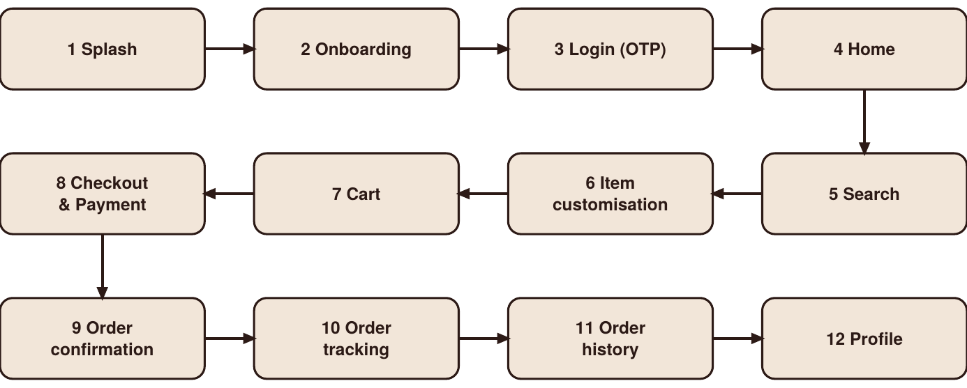
Figure 1: User flow of a new user

4.5 Navigation Structure
After login the product uses a persistent bottom navigation bar with four tabs: Home, Search, Orders and Profile. The active tab is shown with a darker icon, a bold label and a small dot beneath it. Secondary screens such as Item Customization, Cart, Checkout, Tracking, Order History and Profile use a back arrow at the top left so that the user can always return. Keeping the tab bar in the same place on every main screen lets users build a mental map of the product and placing it at the bottom keeps every destination within reach of the thumb.

5. Wireframes

5.1 Purpose of Wireframes
Before the final visual design, the structure of each screen was planned as a low-fidelity wireframe. A wireframe shows the position and relative size of content blocks without colour, imagery or detailed typography. This allows decisions about layout, hierarchy and navigation to be made and changed quickly. In the wireframes below, grey boxes represent content blocks, crossed boxes represent images and dark boxes represent primary actions.

Wireframe 1: Login
The login wireframe is kept very simple. A back arrow is placed at the top left, followed by a logo space and the greeting Hey bhai, welcome! The only input is a single mobile number field with a +91 prefix, so the user has to type only ten digits. The Send OTP button is placed directly below the field and has the strongest visual weight. Below an “or continue with” line, two outline buttons offer Google and Apple sign-in for users who prefer them. The layout has one clear path and no extra elements, which keeps the first interaction with the app quick.
Wireframe 2: Home
The home wireframe sets out the structure of the main screen. At the top are the delivery location (Indiranagar, BLR) and a profile icon, followed by a search bar. A wide banner block holds the Do Bhai Special offer of ₹50 off on the first order, which is the main promotion. Below it, four round category buttons (Cold, Espresso, Hot and Snack) let users filter the menu. The section Bhai’s favourites uses a two-column grid of product cards, each with an image space, a name and a + button for quick adding. The bottom navigation bar with four icons stays at the bottom of the screen, so that Home, Search, Orders and Profile are always within thumb reach.
Wireframe 3: Item Customisation
This wireframe separates the choices for one drink from the rest of the app. A large image block is placed at the top, with a favourite icon in its corner. Under it come the item name, price, veg marker and rating (Hazelnut Cold Coffee, ₹180, veg, 4.8). The options follow in a fixed order: Size as three chips (Regular, Medium, Large), Milk as two radio rows (Oat milk +₹30 and Almond milk +₹40), and Sweetness as three chips (No, Less, Regular). Each extra cost is written beside its option. The sticky bottom button reads Add to cart · ₹210, so that the total price is always visible and changes as the user selects options.
Wireframe 4: Cart
The cart wireframe is planned so that the user can check everything before paying. The screen title shows the number of items (Your bag (2)), and each item has its own card with an image space, name, price and quantity stepper. Below the items, a row of tip chips (None, ₹20, ₹30 and ₹50) allows the user to thank the delivery partner, and a dashed banner confirms that the coupon BHAI50 has been applied. The bill card lists the item total, fees and taxes, tip, discount and final total in a simple aligned list. The dark Checkout · ₹310 button at the bottom repeats the final amount, so no price surprises appear at the next step.
Wireframe 5: Checkout & Payment
The checkout wireframe groups the last steps of the order into three clear blocks. The first block is the delivery address card with a Change link, followed by a text box for delivery instructions. The second block, Pay your way, lists the payment methods: UPI is expanded and shows Google Pay, PhonePe and Paytm as radio options, while Cards and COD are shown as collapsed rows with arrows, which keeps the screen short. The third block is a summary row with the number of items and the total (2 items · Total ₹310). The primary button Pay ₹310 · Place order stays fixed at the bottom of the screen, so the final action is always easy to find.
Wireframe 6: Order Tracking
The tracking wireframe is designed to reduce the waiting anxiety after payment. The title shows the order number, and a large map block takes the upper part of the screen, with markers for the café, the delivery partner and the home address. Below the map, the headline Almost there! and the name of the delivery partner appear next to a small badge with the remaining time (12 min). A four-step progress indicator (Confirmed, Brewing, On the way and Done) shows the stage of the order. The delivery partner card shows the initials, name and rating (Rajesh K., 4.9) with call and chat icons, and the last card repeats the delivery address (Delivering to Home). The bottom navigation bar remains visible so that the user can leave and return easily.

5.2 Wireframes of the Main Screens

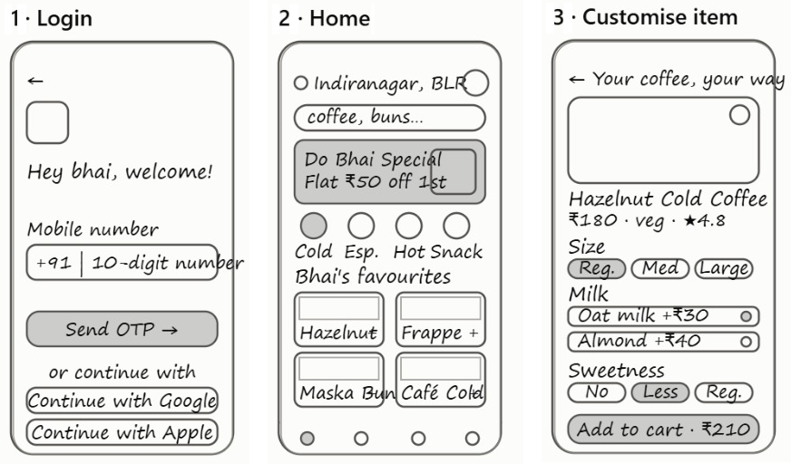
Figure 2: Wireframes of the Login, Home and Item Customisation screens
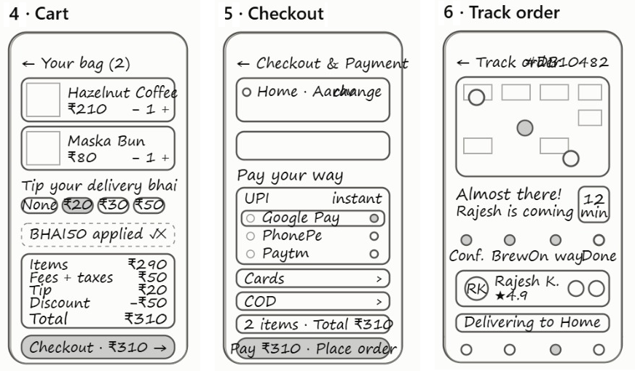
Figure 3: Wireframes of the Cart, Checkout & Payment and Order Tracking screens

5.3 Structural Decisions
Several structural decisions were made at the wireframe stage:
- A persistent bottom navigation bar with Home, Search, Orders and Profile, so that the position of every main destination stays the same and stays within thumb reach.
- A sticky primary action button at the bottom of the item, cart and checkout screens (Add to Cart, Proceed to Checkout, Pay and Place Order), so that the next step is always visible and shows the current price.
- Chips and radio rows for choices such as size, sweetness, tip, price range and payment method, so that users select with a single tap instead of typing.
- Card-based content for items, bill, address, delivery partner and orders, which makes each block easy to scan.
- A separate customisation screen so that the home and search lists stay simple while all options appear only when the user needs them.
- A pop-up confirmation over the checkout screen so that the user receives clear feedback without leaving the context of the payment.

6. UI Design and Prototype
All screens were designed in Figma as mobile frames in an iPhone-style layout (390 px wide, exported at 390 x 884) and linked together in a clickable prototype. Figure 4 gives an overview of all twelve screens in the order of the user journey, and Table 5 summarises the purpose of each screen.
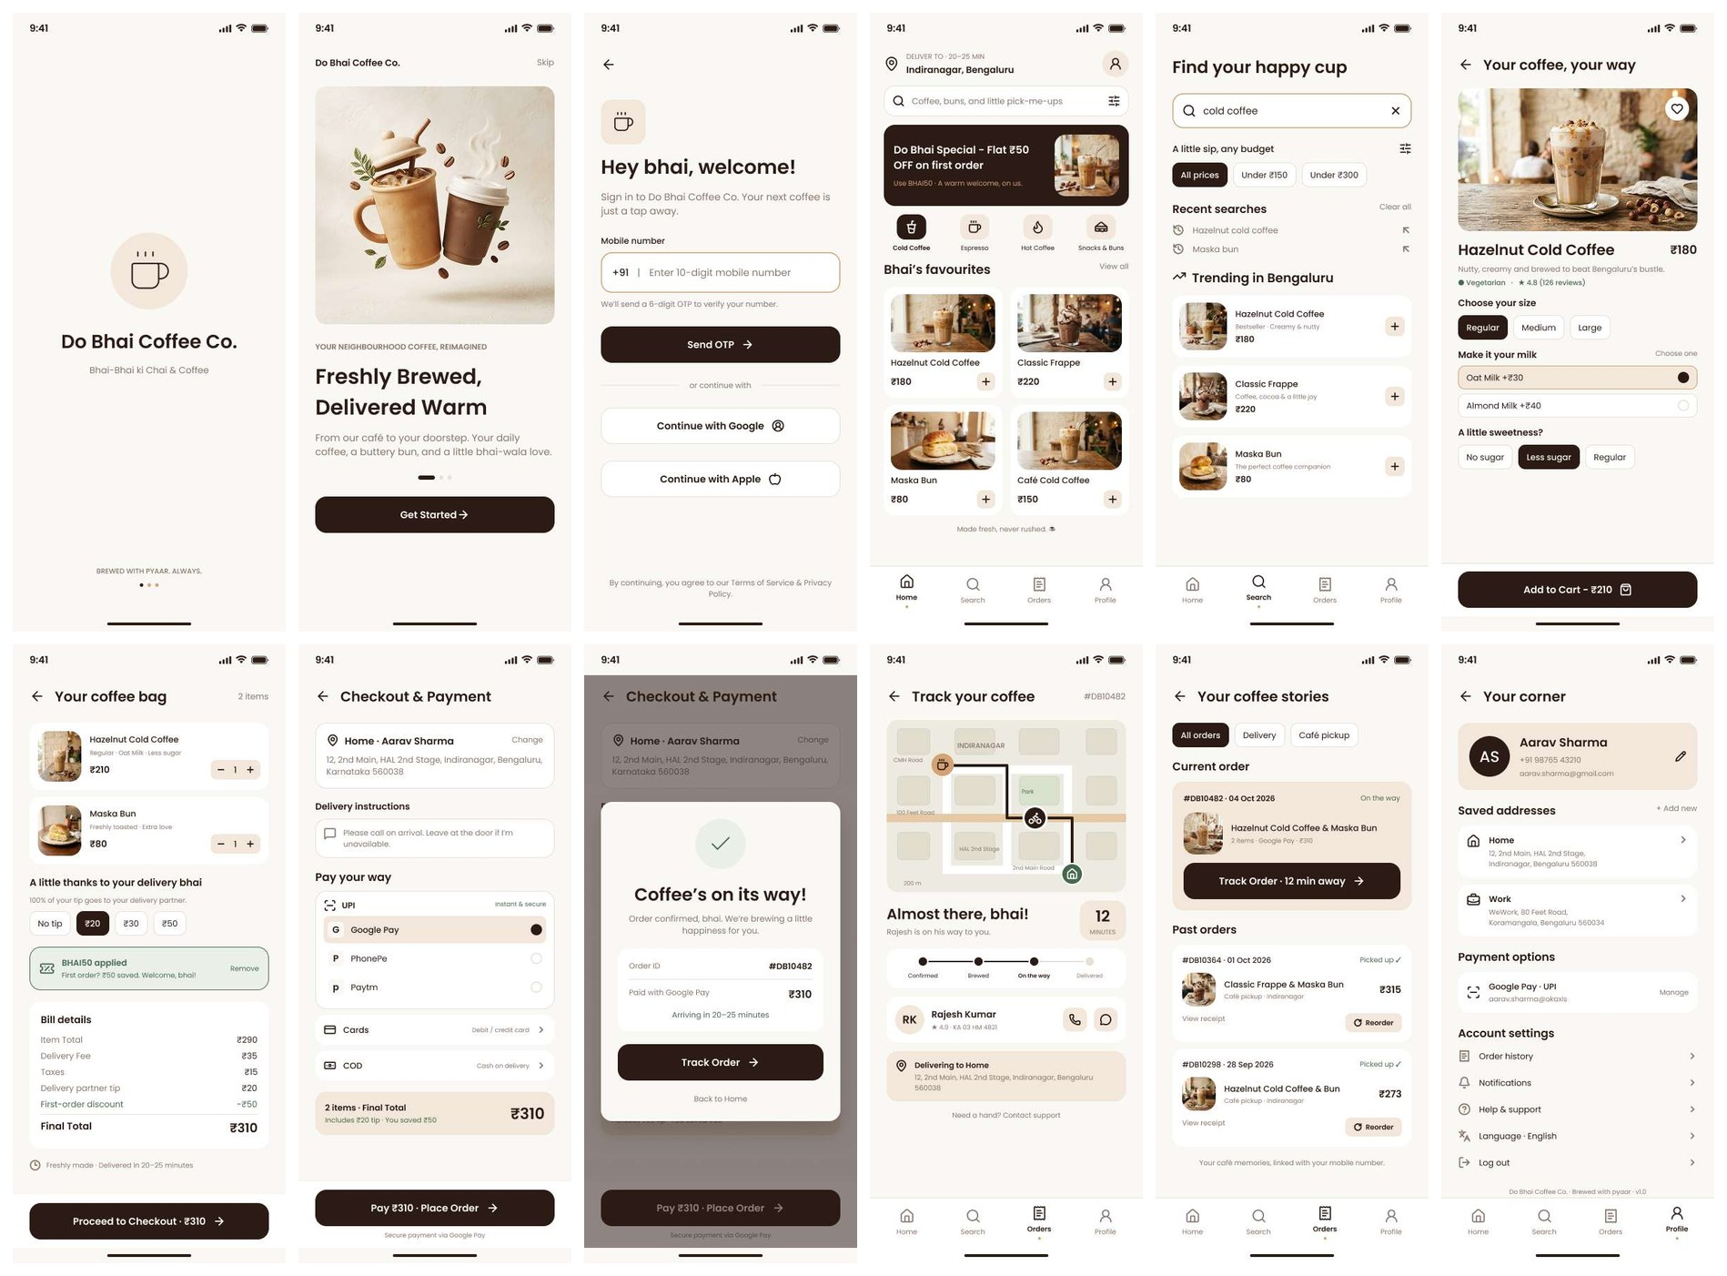
Figure 4: All twelve screens of the Do Bhai Coffee Co. app in journey order: Splash, Onboarding, Login, Home, Search, Item Customisation, Cart, Checkout & Payment, Order Confirmation, Order Tracking, Order History and Profile
Table 5: Summary of the twelve screens
No. | Screen | Purpose | Main action
1 | Splash | Show the brand identity while the app opens | None (automatic)
2 | Onboarding | Explain the value of the product | Get Started
3 | Login | Sign in with mobile number and OTP, Google or Apple | Send OTP
4 | Home | Show location, offer, categories and favourites | Add (+) an item or open it
5 | Search | Find items with price filters, recent and trending lists | Add (+) an item
6 | Item Customisation | Choose size, milk and sweetness | Add to Cart
7 | Cart | Review items, tip, coupon and bill | Proceed to Checkout
8 | Checkout & Payment | Confirm address, instructions and payment method | Pay and Place Order
9 | Order Confirmation | Confirm the order with ID, amount and arrival time | Track Order
10 | Order Tracking | Follow the delivery partner and order status | Call or chat with partner
11 | Order History | View current and past orders | Track Order / Reorder
12 | Profile | Manage account, addresses, payment and settings | Edit / Manage

6.1 Design Principles
Five principles guided the visual design. Clarity: every screen has one main purpose and one main action. Consistency: colours, spacing, corner radius and component styles are reused everywhere. Feedback: the live price on buttons, the applied-coupon banner, the confirmation pop-up and the tracking steps tell users what is happening. Simplicity: generous space and short labels keep the interface calm. Warmth: friendly microcopy, round shapes and café photography give the app a neighbourhood character.

6.2 Design System
Table 6: Design system summary
Element | Use in the design
Cream (about #FAF7F4) | Screen backgrounds, giving a warm and calm base
White (#FFFFFF) | Cards, input fields and unselected chips, lifted gently from the cream background
Espresso brown (about #2C1A16) | Primary buttons, selected chips, headings and active navigation items
Latte beige (about #F2E6D9) | Selected rows, quantity steppers, icon buttons, total summary and profile card
Sage green tint and green text | Success and reassurance: coupon applied, Vegetarian marker, Picked up status and order tick
Tan outline | Focus state of the active input, such as the search field and mobile number field
Rounded geometric sans-serif (Poppins style) | Headings in semi-bold, and labels and body text in regular and medium weights; small grey text for hints
Corner radius | Large rounded corners on cards, buttons and chips for a soft and friendly look
Icons and imagery | Simple outline icons (cup, bag, pin, receipt, bike) and warm café photographs of coffee and buns
Components | Primary button, outline button, chips, radio rows, quantity stepper, product card, order card, coupon banner, bill card, status stepper, bottom navigation bar and pop-up

6.3 Splash Screen
The splash screen shows the Do Bhai Coffee Co. name in bold type below a coffee-cup icon on a soft beige circle, with the tagline Bhai-Bhai ki Chai & Coffee. At the bottom, the line Brewed with pyaar. Always. and three small dots complete the brand moment. The empty cream space keeps the screen calm and lets the logo be the only focus.

6.4 Onboarding Screen
The onboarding screen has a large illustration of an iced and hot coffee surrounded by coffee beans and leaves, the label Your neighborhood coffee, reimagined and the headline Freshly Brewed, Delivered Warm. A short description (From our café to your doorstep. Your daily coffee, a buttery bun, and a little bhai-wala love.) explains the idea. A pill-shaped page indicator, a Skip link at the top right and a single dark Get Started button give the user a clear choice without distraction.

6.5 Login Screen
The login screen is headed Hey bhai, welcome! And keeps the form to one field: a 10-digit mobile number with a +91 prefix. The field is outlined in tan when active. A hint below says that a 6-digit OTP will be sent to verify the number, and a dark Send OTP button completes the action. For users who prefer it, Continue with Google and Continue with Apple are provided after an or continue with divider. A line at the bottom links the Terms of Service and Privacy Policy, and a back arrow prevents the user from getting stuck.
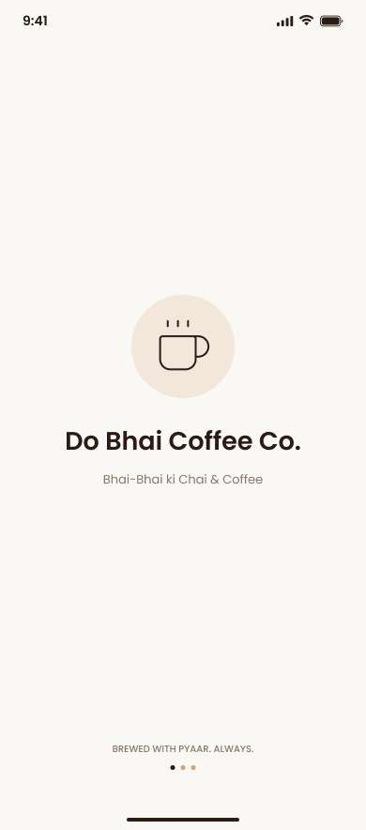 | 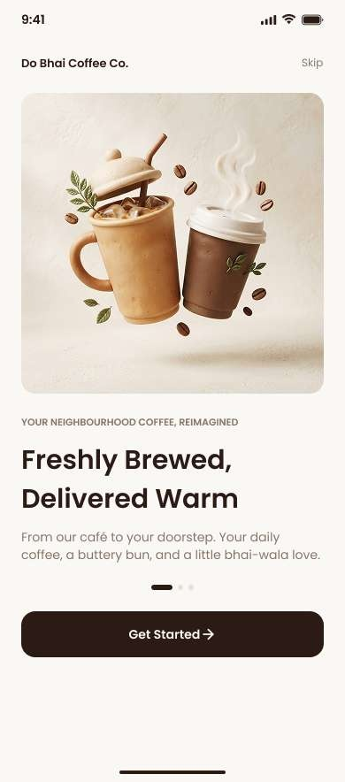 | 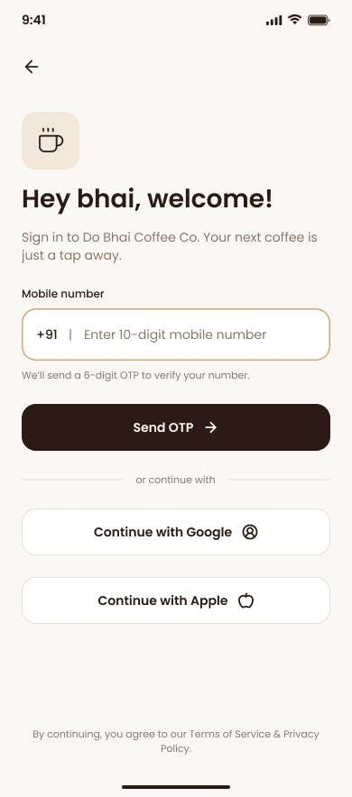
Figure 5: Splash, onboarding and login screens

6.6 Home Screen
The home screen starts with the delivery area and time (Deliver to · 20–25 min, Indiranagar, Bengaluru) and a profile button. Below it is a search bar with a filter icon and a dark promotional banner, Do Bhai Special – Flat ₹50 OFF on first order, with the code BHAI50. Four category buttons (Cold Coffee, Espresso, Hot Coffee and Snacks & Buns) follow, with the selected category in dark brown. The Bhai’s favorites section shows a two-column grid of product cards with photos, names, prices and a + button: Hazelnut Cold Coffee (₹180), Classic Frappe (₹220), Maska Bun (₹80) and Café Cold Coffee (₹150). The line Made fresh, never rushed. closes the page, and the bottom navigation bar shows Home as the active tab.

6.7 Search Screen
The search screen is titled Find your happy cup. The search field shows the typed text (cold coffee) with a clear (X) icon and a tan outline. Under A little sip, any budget, price chips (All prices, Under ₹150 and Under ₹300) and a filter icon let users narrow the list. Recent searches (Hazelnut cold coffee, Maska bun) can be reused with one tap or removed with Clear all. Trending in Bengaluru lists Hazelnut Cold Coffee (Bestseller · Creamy & nutty, ₹180), Classic Frappe (Coffee, cocoa & a little joy, ₹220) and Maska Bun (The perfect coffee companion, ₹80) as list cards with a + button.

6.8 Item Customisation Screen
The item screen, titled Your coffee, your way, shows a large photo of Hazelnut Cold Coffee with a heart button for favourites. Below are the name and base price (₹180), a short description (Nutty, creamy and brewed to beat Bengaluru’s bustle.), a green Vegetarian marker and a rating of 4.8 from 126 reviews. The user chooses a size (Regular, Medium or Large), a milk option marked Choose one (Oat Milk +₹30 or Almond Milk +₹40) and a level of sweetness (No sugar, Less sugar or Regular). The dark bottom button updates the price as the choices change: with Regular size, Oat Milk and Less sugar it reads Add to Cart – ₹210, which is the base ₹180 plus ₹30 for oat milk.
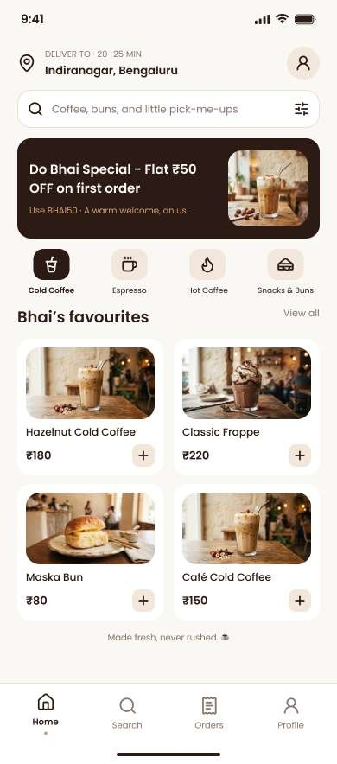 | 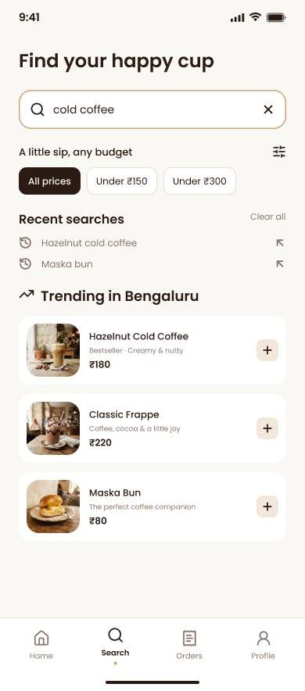 | 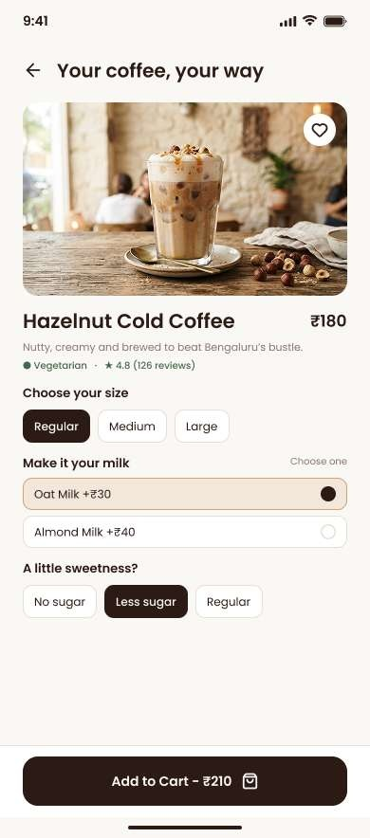
Figure 6: Home, search and item customisation screens

6.9 Cart Screen
The cart, titled Your coffee bag, shows the number of items (2 items) and a card for each item with a photo, the chosen options and a quantity stepper. The Hazelnut Cold Coffee card reads Regular · Oat Milk · Less sugar at ₹210, and the Maska Bun card reads Freshly toasted · Extra love at ₹80. The section A little thanks to your delivery bhai explains that 100% of the tip goes to the delivery partner and offers chips for No tip, ₹20, ₹30 and ₹50, with ₹20 selected. A green banner confirms BHAI50 applied (First order? ₹50 saved. Welcome, bhai!) with a Remove option. The Bill details card lists every component of the price, and a note says Freshly made · Delivered in 20–25 minutes. The dark button Proceed to Checkout · ₹310 repeats the final amount.
Table 7: Bill breakdown shown on the cart screen
Bill item | Amount
Item Total (₹210 Hazelnut Cold Coffee + ₹80 Maska Bun) | ₹290
Delivery Fee | ₹35
Taxes | ₹15
Delivery partner tip | ₹20
First-order discount (BHAI50) | −₹50
Final Total | ₹310

6.10 Checkout and Payment Screen
The checkout screen, titled Checkout & Payment, begins with the delivery address card (Home · Aarav Sharma, 12, 2nd Main, HAL 2nd Stage, Indiranagar, Bengaluru, Karnataka 560038) with a Change link. Under Delivery instructions, a text box holds a note such as Please call on arrival. Leave at the door if I’m unavailable. The Pay your way section is grouped by type: UPI (labelled Instant & secure) expands to Google Pay, PhonePe and Paytm as radio rows, with Google Pay selected, while Cards (Debit / credit card) and COD (Cash on delivery) are collapsed rows with arrows. A beige summary card repeats 2 items · Final Total ₹310 with Includes ₹20 tip · You saved ₹50. The bottom button Pay ₹310 · Place Order carries the line Secure payment via Google Pay beneath it.

6.11 Order Confirmation Screen
After payment, a pop-up appears over the dimmed checkout screen. It shows a green tick, the headline Coffee’s on its way! and the message Order confirmed, bhai. We’re brewing a little happiness for you. A white card lists the Order ID (#DB10482), the payment method and amount (Paid with Google Pay, ₹310) and the arrival time (Arriving in 20–25 minutes). The primary button Track Order leads to tracking, while the text link Back to Home offers an exit.
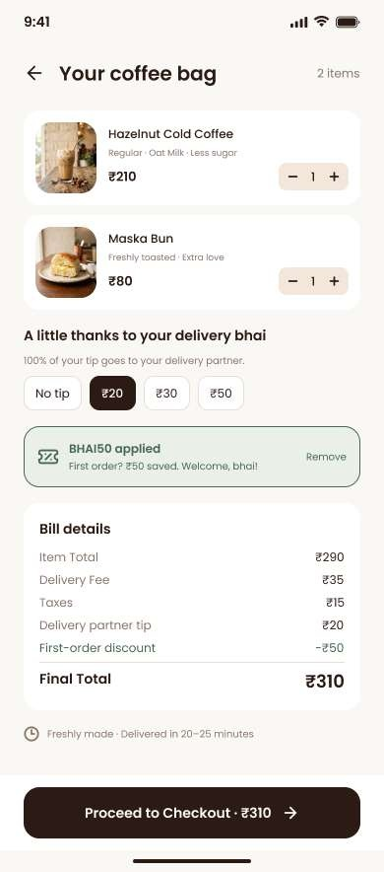 | 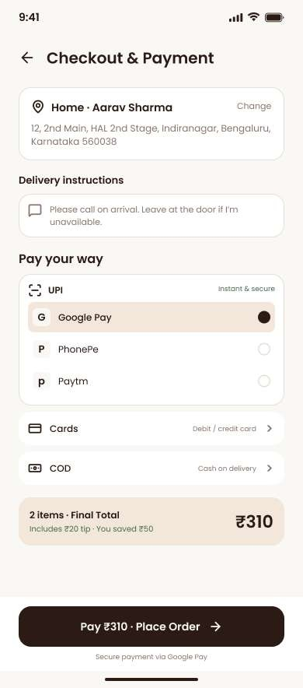 | 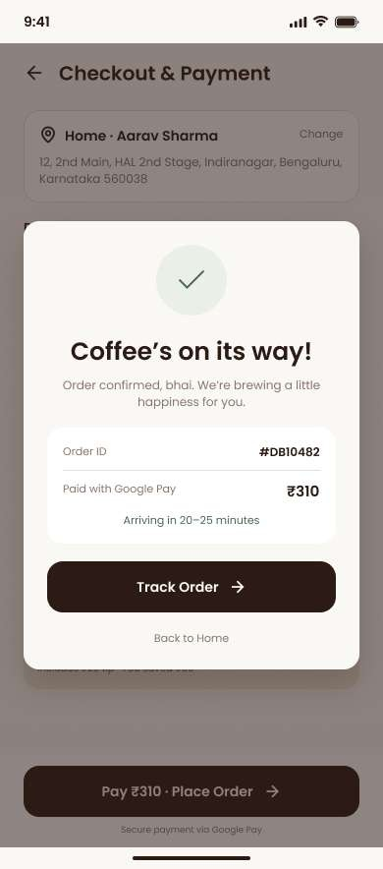
Figure 7: Cart, checkout and order confirmation screens

6.12 Order Tracking Screen
The tracking screen, titled Track your coffee with the order number #DB10482, shows a simplified map of Indiranagar with the CMH Road, 100 Feet Road, HAL 2nd Stage and 2nd Main Road labels, a park, a scale (200 m), the café pin, the rider icon and the home pin joined by a dark route line. Below the map, the headline Almost there, bhai! and the line Rajesh is on his way to you. sit beside a beige badge showing 12 MINUTES. A four-step progress bar (Confirmed, Brewed, On the way, Delivered) highlights the current step. The delivery partner card shows the initials RK, the name Rajesh Kumar, a rating of 4.9 and the vehicle number KA 03 HM 4821, with round call and chat buttons. A beige card repeats Delivering to Home with the address, and the link Need a hand? Contact support is placed at the bottom. The Orders tab is active in the bottom navigation.

6.13 Order History Screen
The order history screen, titled Your coffee stories, has filter chips for All orders, Delivery and Café pickup. The Current order card (#DB10482 · 04 Oct 2026, status On the way) shows the items (Hazelnut Cold Coffee & Maska Bun), the number of items, the payment method and the amount, and a dark button Track Order · 12 min away. Under Past orders, cards for #DB10364 (01 Oct 2026, Classic Frappe & Maska Bun, ₹315) and #DB10298 (28 Sep 2026, Hazelnut Cold Coffee & Bun, ₹273) are marked Picked up in green, with a View receipt link and a beige Reorder button. The footer line Your café memories, linked with your mobile number. reinforces that the history is tied to the account.

6.14 Profile Screen
The profile screen, titled Your corner, starts with a beige card showing the initials AS, the name Aarav Sharma, the mobile number and the email, with an edit (pencil) icon. Saved addresses lists Home (12, 2nd Main, HAL 2nd Stage, Indiranagar) and Work (WeWork, 80 Feet Road, Koramangala) with an Add new link. Payment options shows the linked Google Pay UPI account with a Manage link. Account settings contains Order history, Notifications, Help & support, Language (English) and Log out as simple list rows with arrows. The version line Do Bhai Coffee Co. · Brewed with pyaar · v1.0 ends the page, and the Profile tab is active in the bottom navigation.
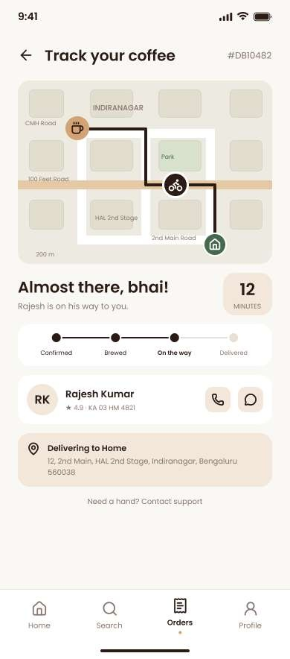 | 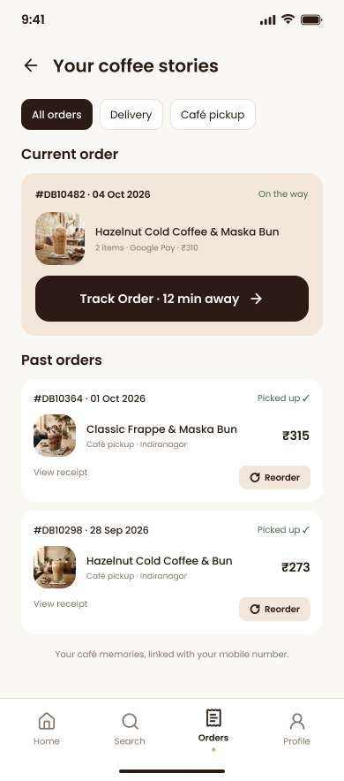 | 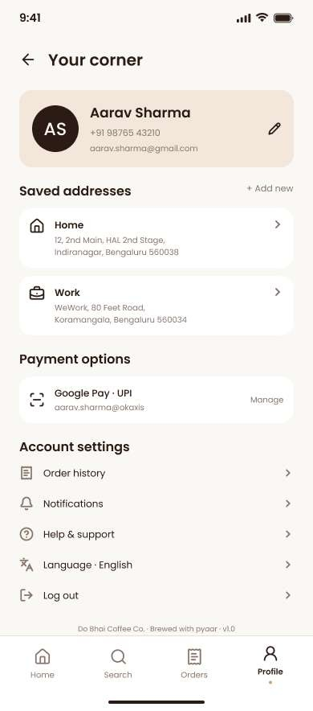
Figure 8: Order tracking, order history and profile screens

6.15 Organisation of the Figma File
The Figma file was organised for reuse and developer hand-off. Each screen of the product is a separate mobile frame named after the screen (for example Splash, Onboarding, Login, Home, Search, Item Customisation, Cart, Checkout, Order Confirmation, Order Tracking, Order History and Profile). Repeated elements such as the primary button, outline button, chips, radio rows, product cards, order cards, the quantity stepper and the bottom navigation bar are built as reusable components so that a change in one place is reflected everywhere. Colours and text styles are defined once and reused, and Auto Layout keeps spacing consistent.

6.16 Prototype
The screens are connected in Figma with interactions so that a user can click through the full journey: splash, onboarding, login, home, search, item customization, cart, checkout, order confirmation, order tracking, order history and profile. Tabs in the bottom navigation, chips, radio selections, the tip selector, the Remove option on the coupon and the Track Order and Reorder buttons are included to show how the interface behaves.
Prototype link: [https://www.figma.com/design/VS3xjn4kImCyvp8C8JBCCV/Project-Final?node-id=0-1&t=Pqxpw6vDZ16C0RnV-1]

7. Testing and Feedback

7.1 Objectives of Testing
The purpose of testing is to find out whether real users can complete the main tasks without help, where they hesitate, and which parts of the design need improvement. Testing is done on the clickable prototype before any code is written, because changes are much cheaper at this stage.

7.2 Method
- Participants: [add number] students and working professionals from the target group.
- Format: moderated, task-based testing on the clickable Figma prototype on a phone-sized screen.
- Tasks: sign in with a mobile number, find the Hazelnut Cold Coffee using search, customize it with oat milk and less sugar, add a tip and check the coupon in the cart, pay with Google Pay, track the order and reorder a past order.
- Measures: task completion, time taken, errors and satisfaction rating.

7.3 Design Review Against Usability Heuristics
In addition to user testing, the design was reviewed against the ten usability heuristics of Jakob Nielsen.
Table 8: Review of the design against usability heuristics
Heuristic | How the design supports it
Visibility of system status | Four-step order progress, ETA badge and map on the tracking screen; live price on the Add to Cart button; current order on the order history screen
Match with the real world | Familiar terms such as UPI, COD and ₹ amounts, a cart named “Your coffee bag”, and warm local microcopy such as “bhai” and “pyaar”
User control and freedom | Back arrows on secondary screens, Skip on onboarding, Remove on the coupon, Change on the address and Clear all on recent searches
Consistency and standards | Same bottom navigation, dark primary button, rounded cards and chips on every screen
Error prevention | Choose one hint on milk options, a 6-digit OTP hint under the mobile field, and the final total shown on the button before payment
Recognition rather than recall | Bottom navigation with icons and labels, recent searches, saved addresses and payment options, and a Reorder button for past orders
Flexibility and efficiency | Quick add (+) buttons, price filters, tip chips, multiple payment methods, Google and Apple sign-in and one-tap reorder
Minimalist design | Generous space and one main action per screen
Help with errors | Planned for the next iteration: inline validation messages for the mobile number and OTP
Help and documentation | Help & support in the profile and a Contact support link on the tracking screen

7.4 Results
Table 9: Task results from user testing
Task | Completed without help | Comments
Sign in with mobile number | [add] | [add]
Find an item using search | [add] | [add]
Customise the drink | [add] | [add]
Add a tip and check the coupon | [add] | [add]
Pay and place the order | [add] | [add]
Track the order | [add] | [add]
Reorder a past order | [add] | [add]

7.5 Feedback and Improvements
Fill in the improvements made after testing, for example changes to button labels, spacing, contrast or navigation. [add feedback and the changes made]

8. Conclusion and Future Scope

8.1 Conclusion
This project produced a complete, consistent UI/UX design for the Do Bhai Coffee Co. mobile app. The design makes it easy for a user to understand the brand, sign in with an OTP, find and customise a drink, see exactly what they will pay, place an order, track it and reorder it later. A warm and limited colour palette, friendly microcopy and reusable components keep the experience simple and personal.
Working through the full design process, from personas and user flows to wireframes, high-fidelity screens and a prototype, showed how each stage reduces risk for the next. Early structural decisions, such as the persistent bottom navigation, the sticky action button and the separate customisation screen, made the final screens easier to design and keep consistent. The project also demonstrated the value of reviewing a design against recognised usability principles before development begins.

8.2 Future Scope
- A tablet and Android-specific version of every screen.
- A dark mode theme.
- A complete café pickup flow, with pickup time selection and a ready-for-pickup status.
- A favourites list linked to the heart button on the item screen, and personalised recommendations.
- Loyalty rewards, repeat-order offers and subscriptions for daily coffee.
- Live map and location integration for real-time tracking and address selection.
- Inline validation, OTP auto-fill and clearer error messages.
- Accessibility improvements such as screen reader support, larger text options and higher contrast, following the Web Content Accessibility Guidelines.
- Support for more languages, such as Hindi and Kannada, through the Language option in the profile.
- Developing the design into a working mobile application with a suitable front-end framework and a back-end for orders, payments and notifications.

